**Project Report Template**

**Title of Project:** Healthcare Assistant Chatbot  
**Name of the Innovator:** Yashaswini.BM  
**Start Date:** 27-10-2025

**End Date: 31-10-2025**

***Day 1: Empathise & Define***

*Step 1: Understanding the Need*

* Which problem am I trying to solve?
* Many people struggle to access timely and reliable healthcare information, appointment scheduling, medication reminders, and basic health guidance. This can lead to delayed treatment, poor health management, and increased strain on medical professionals.
* Who is affected by this problem?  
  Patients, especially those in rural or remote areas, elderly individuals, and people with busy schedules are most affected. Healthcare professionals and clinics also face challenges due to increased workload and limited communication with patients.

*Step 2: What is the problem?*  
There is a lack of easily accessible, reliable, and personalized healthcare support for patients. Many individuals face difficulties in getting quick medical advice, managing appointments, tracking medications, and understanding health information, which affects their overall well-being.

Why is this problem important to solve?

Solving this problem is important because timely access to healthcare information and support can improve patient outcomes, reduce hospital visits, and help people manage their health more effectively. It also lessens the burden on healthcare professionals by automating routine tasks and improving communication between patients and doctors.

**Take-home task**

Ask 2-3 people what they think about the project:

* **1. Student (Rural College Student):**  
  “I think this app is really useful because we usually don’t know which courses or jobs are right for us. If the app can guide us and show nearby colleges or training centers, it will really help students like me plan our future better.”
* **2. Teacher (Career Guidance Teacher):**  
  “This project can make a big difference for rural students. Many of them have potential but don’t get the right information at the right time. A platform like CareerPath can make career counseling easier and more accessible.”
* **3. Parent (From a Rural Area):**  
  “I like this idea because it helps our children know about jobs and scholarships. Sometimes we don’t know where to look for such information. This app can save time and guide families like ours.”
* ”

*AI Tools you can use for Step 1 and 2:*

**AI Tools Used:**

**1. Meta MGX**

* **Used as a no-code development tool to design and deploy the *CareerPath* app.**
* **It helps create interactive workflows, user interfaces, and logic without programming.**
* **Ideal for building features like user registration, location-based data, and skill modules.**

**2. ChatGPT**

* **Used for idea generation, content structuring, and chatbot conversation design.**
* **Helped in framing the AI-powered virtual assistant’s responses for guiding students.**
* **Also useful for generating career recommendations, FAQs, and improving user interaction flow.**

**3. Chatbot References (Structure Design):  
To design the AI virtual assistant, you can take reference from:**

* **Google Dialogflow – for understanding intent detection and response flow.**
* **IBM Watson Assistant – for creating structured Q&A and personalized career guidance.**
* **Microsoft Bot Framework – for understanding conversation trees and user profile integration.**

***Day 2: Ideate***

*Step 3: Brainstorming solutions*

* List **at least 5 different solutions** (wild or realistic):
* **AI Chatbot for Career Guidance** – A virtual assistant that helps students choose the right career and find job opportunities.
* **Skill Learning Website** – A platform to improve communication, aptitude, and soft skills through online lessons.
* **Career Awareness Workshops** – Conducting offline or online sessions in rural schools and colleges to guide students.
* **Mobile App for Scholarship Updates** – Sends alerts about available scholarships and government schemes.
* **Community Mentor Program** – Connects students with mentors or professionals from nearby areas for real guidance.
* **CareerPath Platform**  – A complete digital platform combining AI guidance, skill modules, and location-based opportunities built using **Meta MGX**, designed to empower rural youth.

*Step 4: My favourite solution:*

*My favorite solution is* ***CareerPath****, a complete digital platform designed to empower rural youth. It combines an* ***AI-powered virtual assistant*** *for personalized career guidance,* ***skill development modules*** *for employability, and* ***location-based suggestions*** *for colleges, training centers, and jobs. Built using* ***Meta MGX****, the app is easy to access, update, and use anytime, making it a* ***long-term, practical, and impactful solution*** *for students in rural areas.*

*Step 5: Why am I choosing this solution?*

I am choosing CareerPath because it combines AI guidance, skill development, and location-based opportunities in one platform. It is easy to use, accessible anytime, and designed to empower rural youth to make informed career decisions.

*AI Tools you can use for Step 3-5:*

**AI Tools for Step 3–5**

**1. Meta MGX**

* Used to **design and build the CareerPath app** without coding.
* Helps create the **AI assistant, skill modules, and location-based features**.

**2. ChatGPT**

* Helps **brainstorm solutions** and generate ideas for career guidance features.
* Can **structure conversations** for the AI virtual assistant.
* Assists in writing content for skill modules, FAQs, and recommendations.

**3. AI Chatbot References (for design and flow)**

* **Dialogflow** – Understands user intent and conversation flow.
* **IBM Watson Assistant** – Helps design structured Q&A for personalized guidance.
* **Microsoft Bot Framework** – Shows how to connect user inputs with recommendations and actions.

**4. AI Research Tools**

* **Google Scholar / Research AI** – For exploring existing solutions and innovative ideas for Steps 3–5.
* **AI Text & Summarization Tools** – Helps summarize solutions, select the best approach, and present them clearly.

*AI Tools you can use for the take-home task:*

**Canva AI/CoPilot AI/Meta AI:** Use these mobile-based tools to generate images for the solution they want to design

***Day 3: Prototype & Test***

*Step 6: Prototype – Building my first version*

What will my solution look like?

* **Home Screen:** Welcomes the user and asks for basic info like age, education, and location.
* **AI-Powered Virtual Assistant:** Chat interface where users can ask about careers, scholarships, and job opportunities.
* **Skill Development Section:** Short modules for English, aptitude, and soft skills with interactive exercises.
* **Location-Based Recommendations:** Map or list showing nearby colleges, training centers, and relevant job options.
* **Profile Dashboard:** Tracks the user’s progress, completed skill modules, and saved opportunities.

**Design Style:**

* Simple, intuitive, and easy to navigate for rural youth.
* Bright and engaging visuals to make learning and exploration fun.
* Mobile-friendly layout for easy access on smartphones.

**Prototype Tools:**

* Built using **Meta MGX**, no coding required, with all features **interactive and testable**.

What AI tools will I need to build this?

**AI Tools Needed to Build CareerPath**

1. **Meta MGX**
   * No-code platform to **design and deploy the app**.
   * Allows building **interactive screens, chat interfaces, and skill modules** without coding.
2. **ChatGPT (or similar LLMs)**
   * To **generate content, conversation flows, and career guidance responses**.
   * Can help **personalize recommendations** for users based on their profile and location.
3. **AI Chatbot Design References**
   * **Google Dialogflow / IBM Watson Assistant / Microsoft Bot Framework**
   * To **structure conversation logic** and handle user queries effectively.
4. **AI Recommendation Tools** *(Optional but useful)*
   * For **matching students with careers, scholarships, and nearby opportunities**.
   * Could use **ML-based ranking algorithms** or **existing AI APIs** for personalization.
5. **AI Data Analysis Tools** *(Optional for insights)*
   * **Python AI libraries (Pandas, Scikit-learn)** or **AI analytics platforms**
   * To analyze user interactions and improve recommendations over time.

What AI tools I finally selected to build this solution?

1. **Chat GPT**
2. **Metamgx**

**< Build The Innovation>**

**<DASHBOAD OF THE TOOL>**

**Tool Link:**  **https://careerpath.mgx.world/**

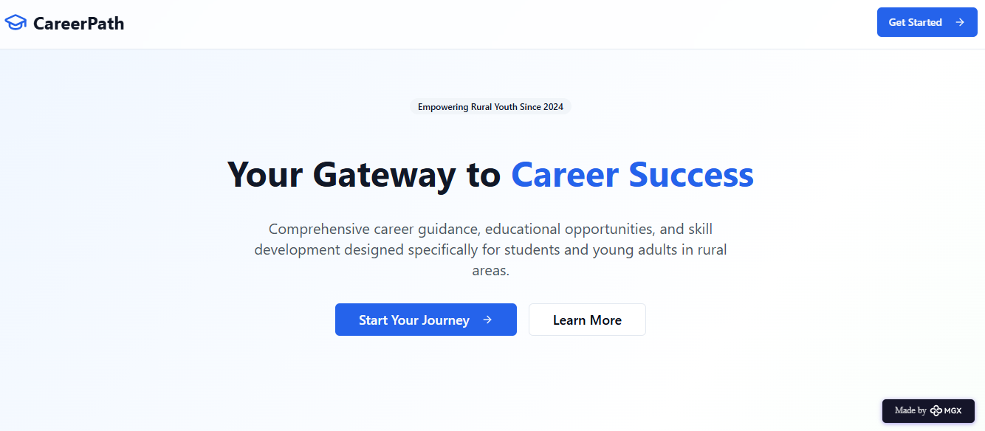

Internal Working of tool:

Profile Creation:

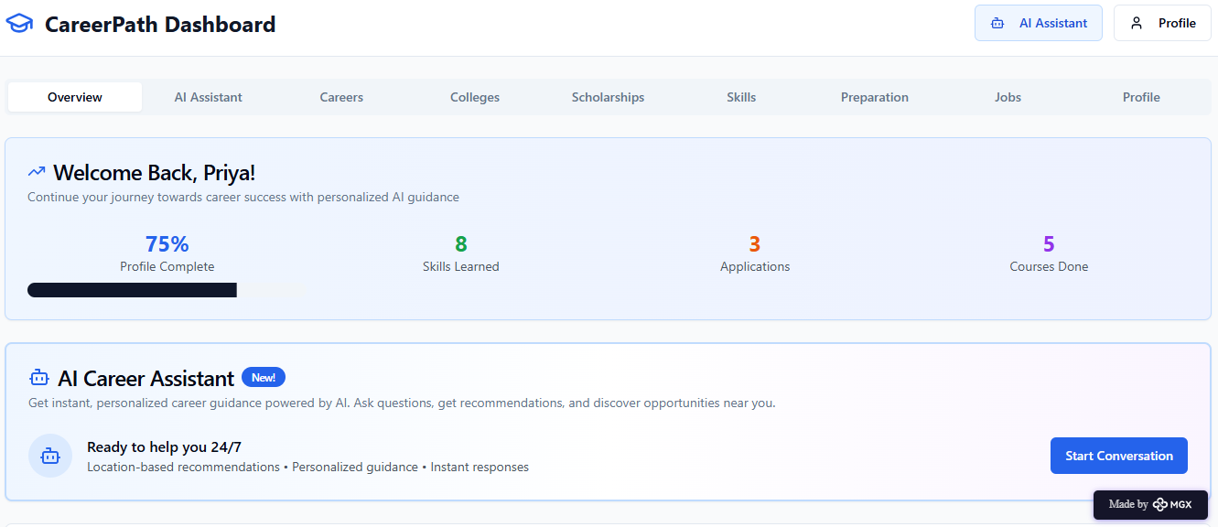

Tailoring recommendations using virtual assistant:

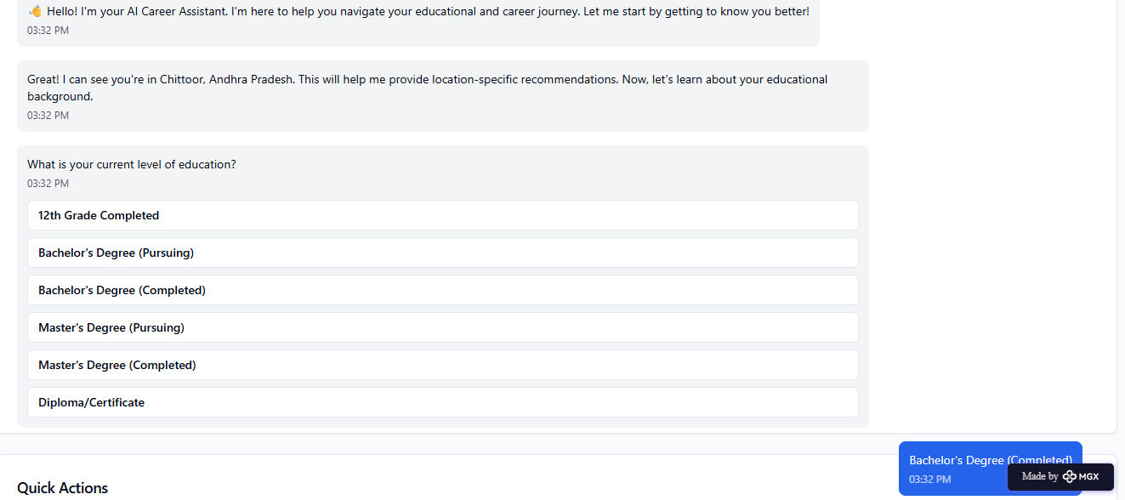

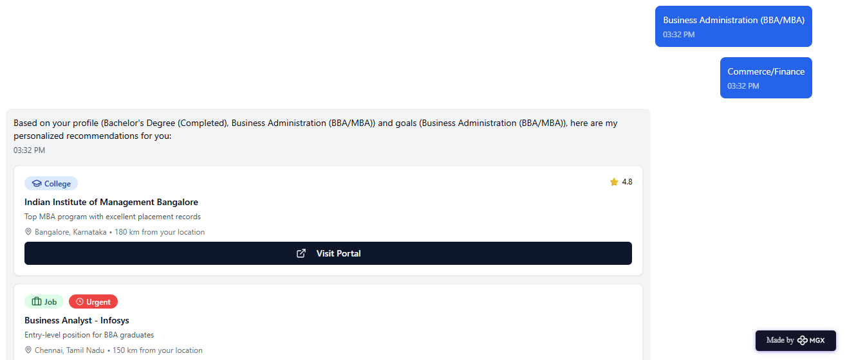

Job Recommendations based on Registered Profile:

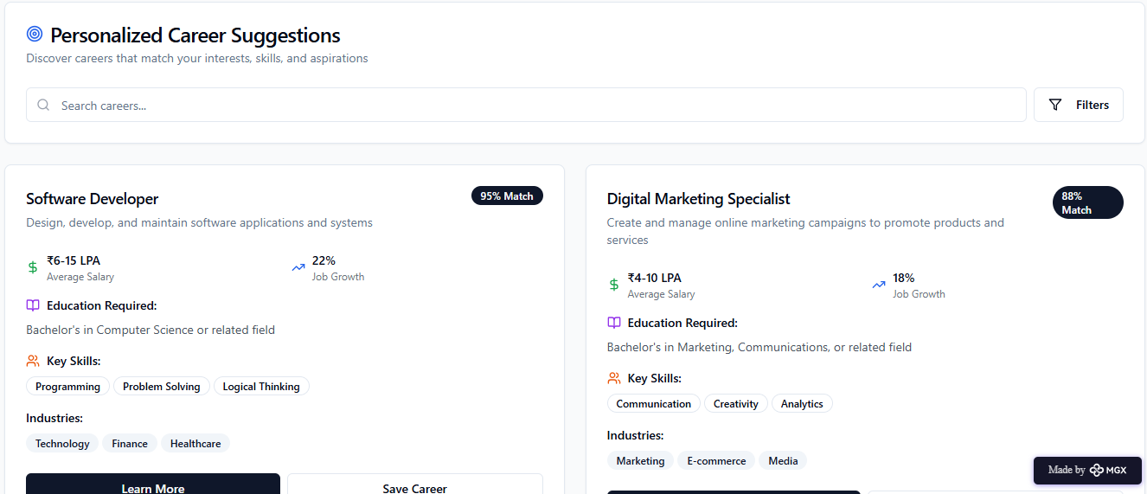

Collage Recommendations based on Profile:

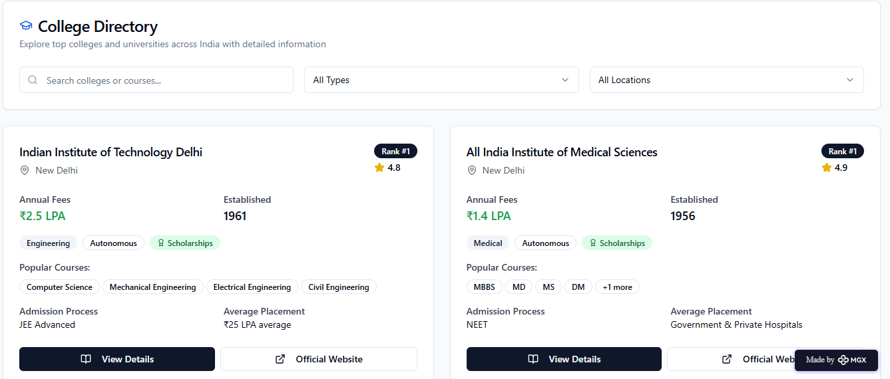

*Step 7: Test – Getting Feedback*

* Who did I share my solution with?

I shared my **CareerPath** solution with:

* **Students from rural areas** – to get feedback on usability and relevance.
* **Teachers and career guidance counselors** – to understand how well it supports career decision-making.
* **Parents of rural students** – to see if it helps families access information about education and jobs.
* **Peers and mentors** – for suggestions on improving features and design.

What feedback did I receive?

**Feedback: Pros and Cons**

**Pros (Positive Insights from Feedback):**

1. Users found the **AI assistant helpful** for exploring career and higher education options.
2. The concept of the platform is **promising** and shows potential for rural youth guidance.
3. Skill modules and location-based suggestions were appreciated as **useful features**.

**Cons (Areas to Improve Noted in Feedback):**

1. Chatbot responses sometimes **repeat options**, which can confuse users.
2. Certain **interactive features are restricted** or not fully accessible in the prototype.
3. Limited resources and integrations mean users can only access a **basic version** of guidance and opportunities.

**My Response for The Feedback:**  
CareerPath is an idea created using a **no-code tool (Meta MGX)**. As it’s an initial prototype, the resources and integrations are limited. To fully integrate all features and access a wider range of career, scholarship, and skill-building resources, we would need **collaborations with different platforms and organizations**. The current limitations are due to the constraints of the prototype environment, but the concept demonstrates the **potential, usability, and impact** of the platform for rural youth.

👍 What works well:

**What Works Well**

* **Lifetime Access:** Unlike other tools, Career Path built on Meta MGX **doesn’t require subscriptions** and can be updated or modified anytime.
* **No-Code Development:** Users can **create and maintain the app without coding knowledge**, making it accessible to students and beginners.
* **Personalized Guidance:** AI assistant provides **tailored career, scholarship, and job recommendations**.
* **Skill Building:** Interactive modules help improve **English, aptitude, and soft skills** for better employability.
* **Location-Based Suggestions:** Students can **discover nearby colleges, training centers, and job opportunities** easily.
* **Mobile-Friendly and Intuitive:** Designed for **easy navigation and continuous accessibility**, even in rural areas.

🔧 What needs improvement:

* **Chatbot Responses:** Currently, the AI sometimes **repeats options**, which can confuse users.
* **Interactive Features:** Some features are **restricted or not fully accessible** in the prototype.
* **Resource Integration:** Limited access to career, scholarship, and skill-building resources.
* **Collaborations Needed:** To expand functionality, partnerships with **other platforms and organizations** are required.
* **User Experience Enhancements:** Further improvements in **navigation, visuals, and engagement** could make the app more intuitive and appealing.

*AI Tools you can use for Step 6-7:*

**ChatGPT/Perplexity AI/Claude AI/Canva AI/Chatling AI/Figma AI/Metamgx/Gamma AI**: You can use these tools to build solutions/models or mock-up dummy prototypes

***Day 4: Showcase***

*Step 8: Presenting my Innovation:*I am presenting **CareerPath**, a **digital career guidance and skill development platform** for rural youth. It features:

* An **AI-powered virtual assistant** that provides personalized career, scholarship, and job guidance.
* **Skill development modules** for English, aptitude, and soft skills.
* **Location-based suggestions** for nearby colleges, training centers, and opportunities.
* A **user-friendly, mobile-friendly interface** built on **Meta MGX** with lifetime access and easy updates.

**Impact:** CareerPath helps students make informed decisions, improves employability, and bridges the guidance gap in rural areas.

**<SHOWCASE YOUR INNOVATION TO YOUR PEERS>**

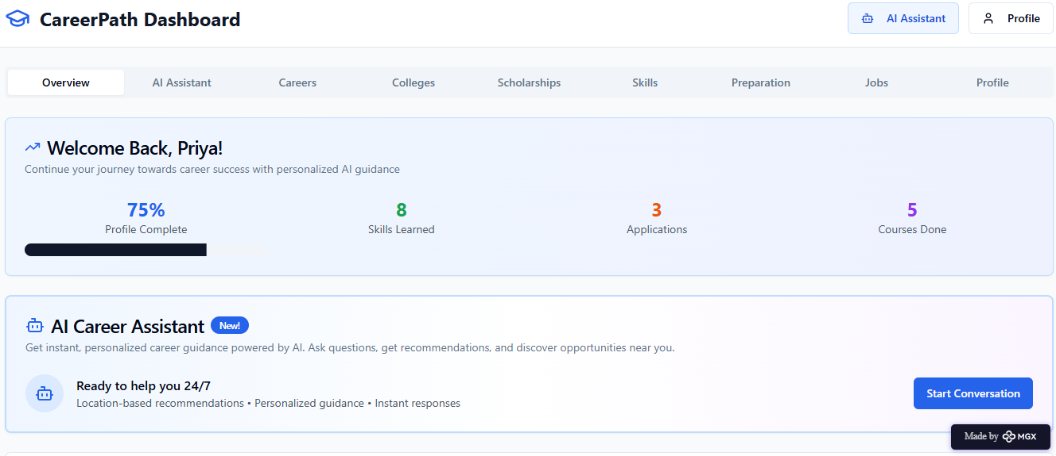

*Step 9: Reflections*

* What did I enjoy the most during this project-based learning activity?

I enjoyed **building CareerPath using a no-code tool** and seeing my idea take a **real, interactive form**. It was exciting to **design the AI assistant, skill modules, and location-based features**, and imagine how it could **empower rural youth** to make better career decisions.

What was my biggest challenge during this project-based learning activity?

My biggest challenge was **integrating all features smoothly** in the prototype using a no-code tool, especially ensuring the **AI assistant, skill modules, and location-based recommendations** worked together effectively with limited resources.

**Take-home task**

<https://github.com/punithhcreator/Careerpath-No-code-application>

*AI Tools you can use for Step 8:*

**Canva AI:** You can use this to design your pitch document. Download your pitch document as a PDF file and upload on GitHub